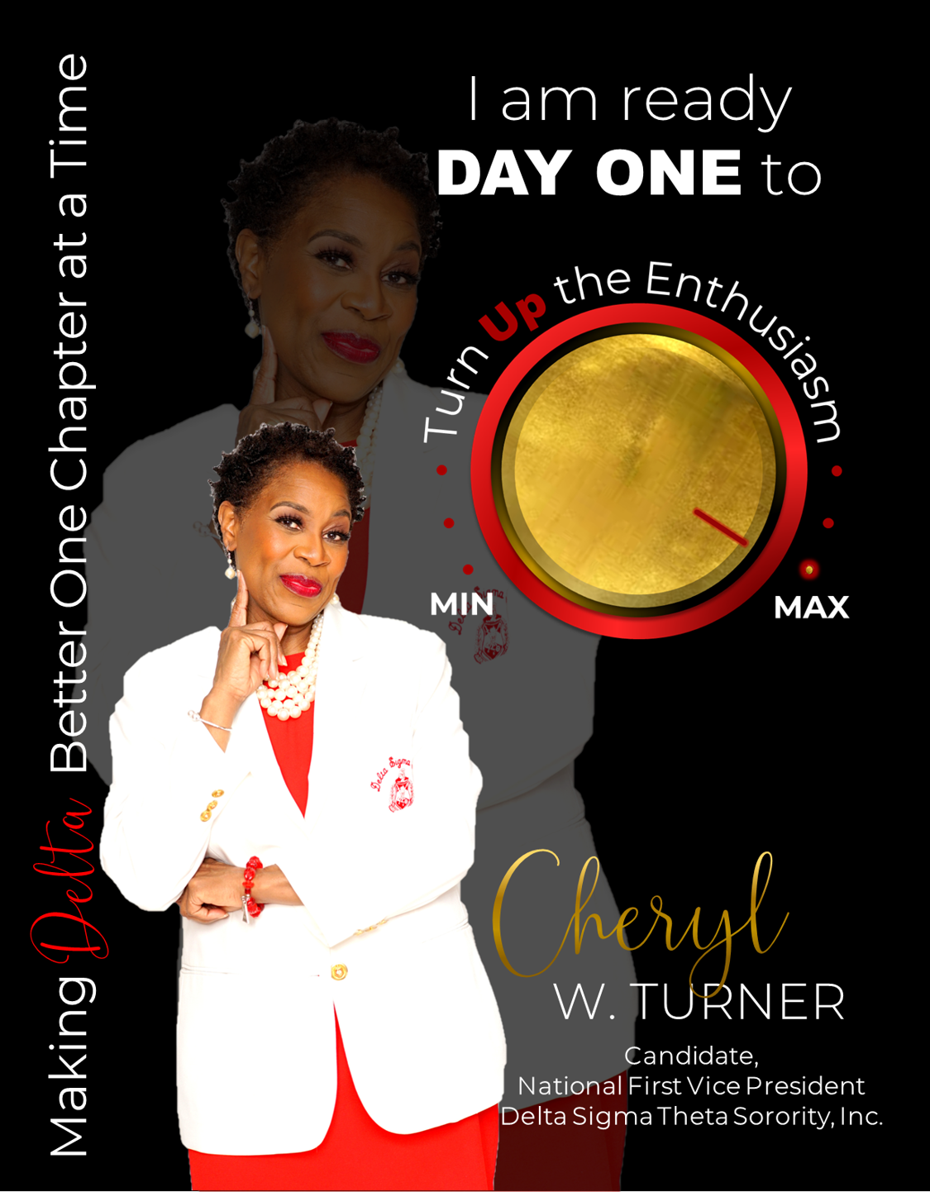
https://turnup4turner1vp.com/

For the Record
Soror, Turn Up the Enthusiasm with me and check out my podcast. For the Record! For the Record presents discussions with leaders across our beloved sorority about chapter operations and leadership challenges.

Click the link below to watch Episodes 1 and 2! Then take a “spin” around my website to learn more about how I am ready on day one, to effectively serve as your National First Vice President.

Get ready to……
Turn Up the Enthusiasm for Making Delta Better One Chapter at a Time!

https://turnup4turner1vp.com/%F0%9F%8E%99%EF%B8%8Ffor-the-record

Soror, thank you for your support
and for sharing your enthusiasm with me!

Zelle: CWTfor1vp@gmail.com
Cashapp:$CWTfor1VP
PayPal: paypal.me/CWTfor1vp

Visit our Website

© 2023 Cheryl W. Turner. The use of a photograph on my campaign literature does not imply an endorsement. Images are intended only to demonstrate actual events that occurred and interactions between individuals photographed. Content should not be copied without permission or shared on social media.

