Greetings Sorors!!!

Springtime is here and chapter fiscal officers are actively preparing the annual financial report of local chapter activities. The position of National Treasurer in Delta Sigma Theta Sorority serves as the Executive Officer responsible for reviewing and reporting all financial activity of the organization, including budgeting, monitoring expenditures, and making recommendations for investments.

As we prepare to elect the next National Treasurer of our beloved sorority,

You may ask …
What are the general qualifications to look for in a National Treasurer?

Qualifications of the National Treasurer include:

- Possession of an advanced degree in Accounting, Finance or Business
- 5 - 10 years of experience in a senior role
- ﻿Experience in finance, budgeting, accounting, auditing, internal controls, and asset management

These qualifications are essential to being an effective financial leader and to ensure the integrity and accuracy of an organization’s financial status.

Now, let’s check DOREEN’s qualifications:
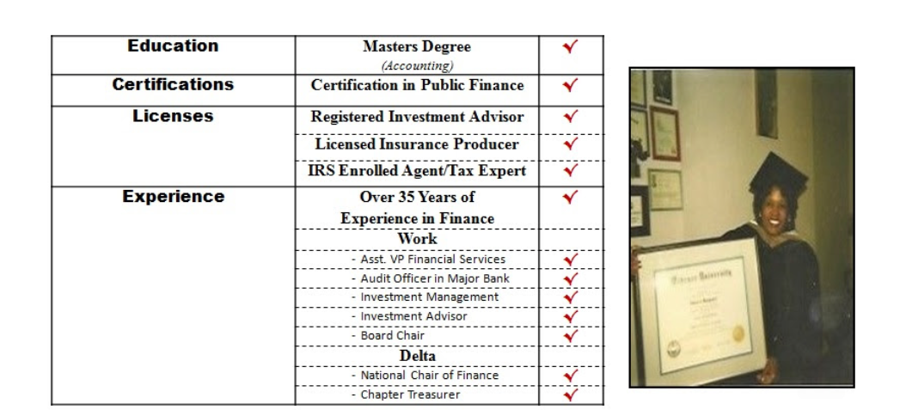
Doreen "checks" all the boxes as the right one to provide “Financial Leadership for Delta’s Future”.

Doreen is ready, willing and able to serve as the next National Treasurer of Delta Sigma Theta Sorority, Inc. To learn more about her leadership and expertise, please review her campaign website by clicking the link below:

Dixon4treasurer.com

Donations for the Campaign to Elect Doreen Dixon for National Treasurer, may be forwarded via CashApp, PayPal or Mail.

