Delta Days at the Nation’s Capital
The Chapter Social Action Chair should attend Delta Days in the Nation’s Capital
The delegate(s) shall provide and present a written report of the conference/convention to the chapter at the next available meeting of the body following the event.

Social Action | Engage, Empower, Elevate
As members of Delta Sigma Theta Sorority, Incorporated we have a duty, by oath, to engage in social action. That duty is rooted in the courage and determination exhibited by the Founders to not only establish our Sorority but participate in the Women's Suffrage Parade of 1913 as their first public event.

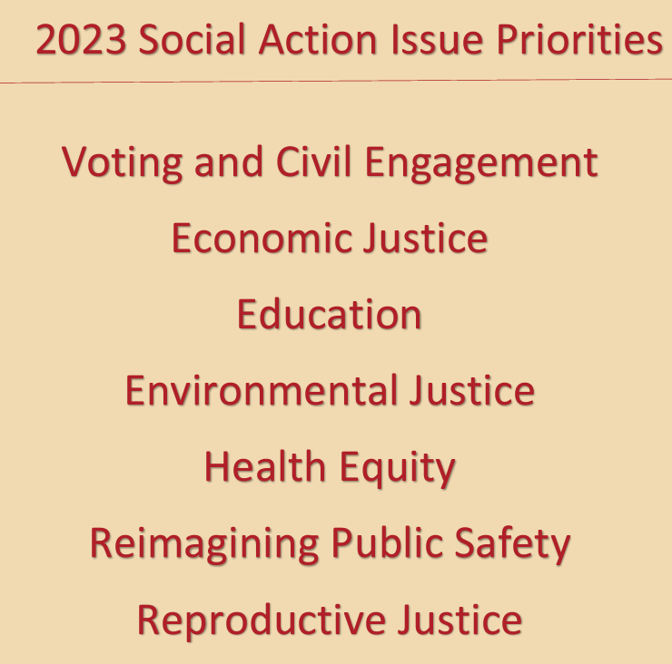

Recap: March 23 - 28, 2023

Outcomes:
- Social Action Priorities - 2023
- DDNC Advocacy Guide - 2023
- Digital Diva Drop resources - 2023
- The National Social Action Commission will be sending the Call for Resolutions for National convention

The Chisholm Jordan Institute Training
Remarks from 26th National President Beverly E. Smith
- 11 members of Delta Sigma Theta Sorority Inc are on US Postal stamps
- Never got an opportunity under President Donald Trump's administration to have a seat at the table and come to the White House It is importance for Delta to have a seat at the table
- The ability to go beyond advocating, but the ability to endorse, speak out, have a seat at the table and push for legislations we can get behind, thus the birth of D4Women in Action
Pat Lattimer moderator:
- Former Senator Brenda Gilmore- if you're not at the table, you're on the menu
- Tammi Grimes - Council Members remarks “If it's not right I'm not with it.
- Senator Natalie Murdock, North Carolina Faith, Family, Finances
Coalition building - Know Your Why, make sure you know your community and have relationships
Valuable fundraiser tips:
- Be consistent
- Establish call time, be dedicated to reaching out to your network
- Be aggressive in your asks, max out the contributions from your supporters
- Know what to do with the funds
- Don't be afraid to ASK

Plenary - Opening - Keep Knocking!
Highlight Notes:
- Do not be distracted by negative responses
- Resistance can be overcome by those who understands there assignment
- Keep asking, keep seeking, for persistence is the key that unlocks the door.
Workshop: What Can We Do About Student Debt?
Highlight Notes:
- Economic Justice is Racial Justice
- Eliminating the debt in which to bridge the racial disparities affecting black and brown people
- Black women owe 2/3 of the student loan debt
- Negotiated rulemaking - new rules the Department of Education come together with for borrowers to abide by and rollout to the citizens
- Black people carry their debt twice as long as their white counterparts
- Student loan debt cancelation is a false correlation for why we are experiencing inflation
- 50% of inflation is associated to CEO salaries
- Push to cancel $50,000 of student loan debt on the federal level
- Need literacy to understand the loan servicers terms and condition, so not to bring the debt clip back
- Push colleges and universities to double the Pell Grant
- Work with your Congressperson
- Student Debt Crisis Center - work with them on individual items
- College Promise - state level for free community college
Plenary : Post 2022 Election, What's Next?: Understanding the Policy and Civic Engagement Landscape
Highlight Notes: Observations from 2022 Election:
Dr. Daley
- Safety Education
- Ballot protection
- Must pay attention to youth vote
Soror Maya Wiley
- Good Day for democracy
- 33 Million Voters, increase turn out
Alpha Phi Alpha Fraternity Inc., Jamal Watkins,
- Money matters, organizing the funds
- Down ballot elections matter
- Bring community members along for the win
Questions and Answer Session
- We must vote out those who do not align with our values. - Jamal Watkins
- When Generation X show up, election results change - Soror Maya Wiley
- We cannot stop regardless of voting laws changes or barriers. Keep educating. Keep the coalitions going. - Soror Thelma T. Daley, National Past President
Plenary - The Delta Research and Educational Foundation
Highlight Notes:
- New leaders in government
- Get involved in all levels in government
This plenary session will feature recently elected Black women who hold political office, seeking political office, or have held political office. The panelists are being asked to share insight about how their leadership will affect positive change for African American women and their families and inspire women to seek elective office.
Workshop Session: Voting Rights: The Fight Continues
- Dominik Whitehead - NAACP VP of Campaigns
- Natalie Murdock - NC Senator
- Nile Bass - DMV Community Organizer
Highlight Notes:
- Access to the ballot looks different, it comes in the form of gerrymandering
- Local elections matter
- State elections matter
Current state of our democracy: Dominik Whitehead
- It's under attack
- We need to understand what is at stake
- Our Power is at the ballot box
LWV - what are they doing to stabilize our democracy: Nile Bass
- Legal battle in the courts
- Vote 411 - district information
- The ballot is intersectional
Meeting voters where they are Fighting and winning in the margins-
How can we do so? Senator Murdock
- Continual work, year around engagement Do drives for other things not just voter registration
- How critical are we to double down on voter registration? To equalize the margins
- Know where you need to be and where to increase black voter turnout, use the data
- Voter Action Network - receive it as MOU from NAACP
- Transition from partisan conversation to issue conversation
- Go from I want to Vote to I need to Vote to I VOTED
How can we get more strategic in our outreach?
- Compare notes on bill filings
- Grow your pod
- We need to focus on down ballot elections and every election cycle
Panel: Give us a CHARGE
- Senator Murdock- Leading the way
- Leaving no voter behind Nile Bass -
- I am forced to be an optimist Jamal Whitehead - Coordination, Collaboration and Communication The Revolution must be financed
Question | Answer
1. How do we build a coalition with non black organizations?
Have conversation with those who have joint ideologies
2. How do you get access to VAN?
VAN training will begin in June for NAACP partners
3. How do we groom better candidates? D4WOMEN in Action
4. Removing polling sites from college campuses?
Look to kill the bill in committee or make bad bills better
Get campus to offer voter registrations as part of student orientation and welcome committee
Voter registration training to register voters
6. What are we doing to be intentional about our young voters?
Platform - twitter.com, newsletter
Start young, coordinate with young people early Partnering with organizations who target youth Ask young people what they care about
7. Discuss Alabama voting case? Gerrymandering and redistricting Create a pipeline for better jurists Care about judicial races
8. Take sample ballots when registering voters
Vote 411
9. Can you offer best practices for voter registration drives?
Train folks from the communities
Organizing is 365 a year
First ask is what is happening in your community
10. What questions should we be asking during candidate night?
Chief of Culture - get more women to join their local LWV League of Women Voters
Delta has a MOU with LWV
11. Formerly incarcerated people, what are we doing to restore their voters?
Look at ballot initiatives
Work with local elections offices to provide accurate information

Social Action Luncheon: Elevating Our Power: Envisioning the Next 60 Years of Social Action Impact
Secretary of Housing and Urban Development - Soror Past President 21st Marcia Fudge
Be like the eagle and sore or be like a chicken getting worms and cackling around Find you some people who have the same work ethic and vision as you

Advocacy Day
- Southwest Region Caucus - broke out by states and directions given by State Coordinators
- Senators to receive the leave behind items from the region to discuss our focus areas

