Delta Sigma Theta Sorority, Inc.
Austin Alumnae Chapter Committee Report
Committee Name: Nominating Committee Committee Chair(s): Carla Grace
Date/Time of meeting: October 17, 2023
Attendees: Carla Grace, LaTasha Robinson, Gloria Frazier, Lisa Newman
Committee Decisions/Discussions:

Committee is following the process outlined in the AAC P&P related to the Chapter Awards Guidelines (Appendix 7 of the P&P)
Chapter Awards are:
DELTA OF THE YEAR VIOLET IN BLOOM
THE FOUNDERS AWARDS
Frederica Chase Dodd ∆ Myra Davis Hemmings ∆ Zephyr Chisom Carter ∆ Jessie McGuire Dent

Committee members are in the process of vetting the nominees for the Chapter Awards balloting.

A summary report will follow when all efforts are completed.

Recommendation(s) to Executive Board: (limit 500 characters)
n/a

Next month’s activities: (limit 500 characters)

Volunteer Activities (Include Date/Tim): (limit 500 Characters)
n/a

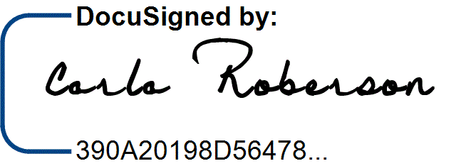
10/17/2023
Signature of soror making the committee report: _
Date of report to Executive Board/Chapter: 10/31/2023
Date/Time of next scheduled committee meeting; October 24, 2023

