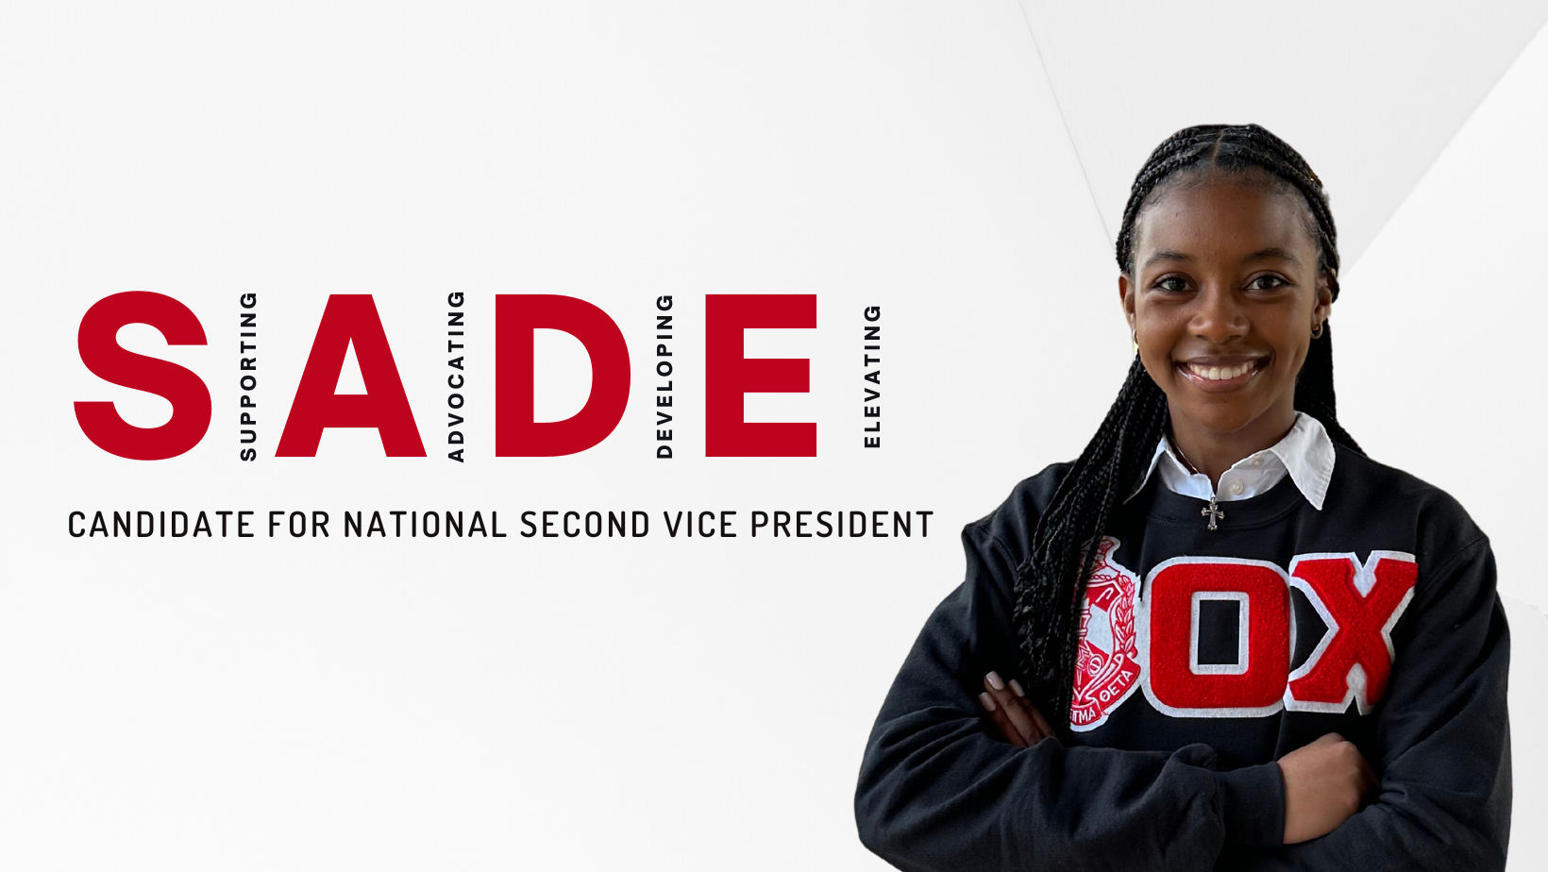
https://www.sadefor2vp.com/

Sorors,

As a Soror based in Silicon Valley, I have the pleasure of being surrounded by some of the world’s most important companies in technology. Every day, I have a front row seat to the inspirational impact that these tools and resources can have on businesses and organizations alike, propelling us towards the future. And as exciting as it may be, I also recognize the challenges and possibly the fear that technology may present. ChatGPT…AI…it’s a lot, am I right?!

As the third pillar in my campaign, I want to help lead our beloved Sorority into the future and carefully advocate for technological efficiency that will help us keep the pulse in this fast-moving world. In addition, I’d like to spearhead efforts to ensure each chapter has the opportunity to leverage everyday tools to the best of their abilities and support our Sorors that need assistance with technology. Many regions have already made great strides, so I’m excited to build upon their great momentum!

Through an initiative called Delta Connect, a support team will be available to provide Sorors and chapters with the following:

- Technical support: Where a team can assist Sorors through the development of FAQ guides with navigating core Sorority tools, like the national website, or even provide support on maintaining and navigating their chapter social media.
- Highlighting chapters: Through takeovers on our instagram account to showcase programming and ideas to their chapters/regions.
- Grouping alumnae Sorors with Collegiates: Through a mentor program, serving as an exchanging wisdom connection.
Learn More

