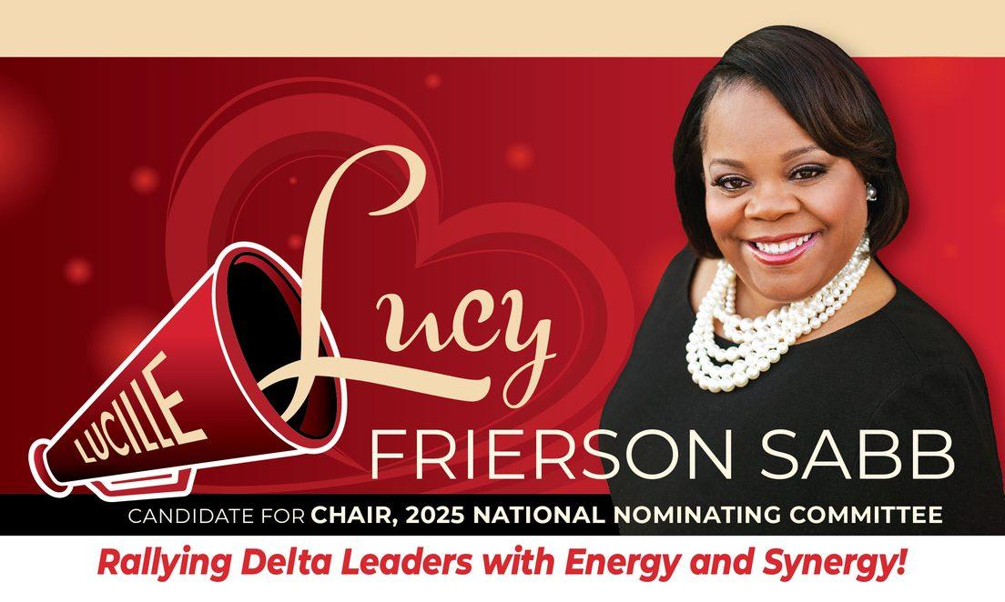
Dear Sorors,
Join us as we “Pass the Megaphone” to meet our candidate for Chair, 2025 National Nominating Committee, Lucille Frierson Sabb.
Be prepared for a fun, engaging, and informative session as you get to know more about the candidate who will rally Delta Leaders with Energy and Synergy!
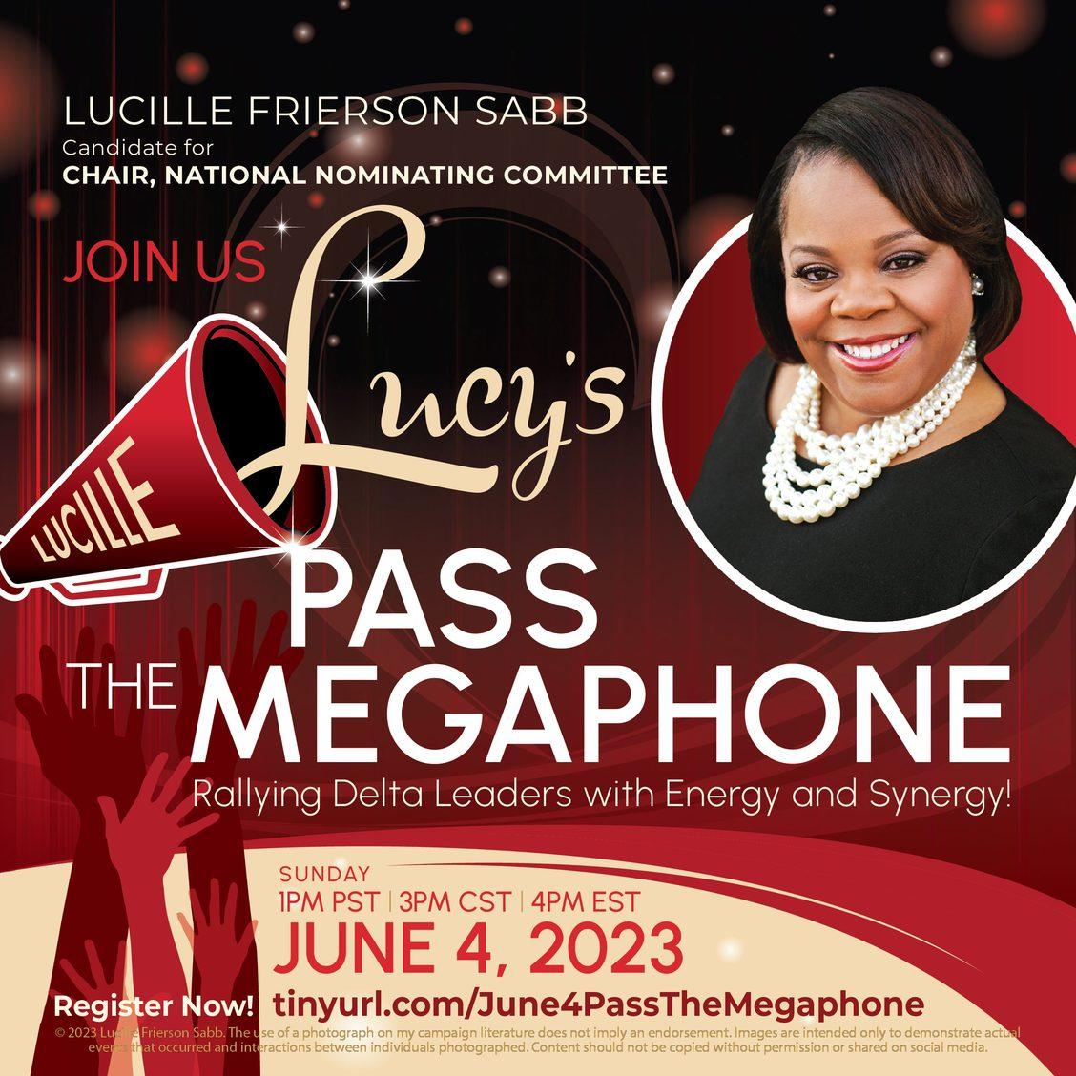
Click Here to Register

With Delta Love,
Lucille Frierson Sabb
704-625-6228
ilovelucy4chair@gmail.com
www.ilovelucy4chair.com
© 2023 Lucille Frierson Sabb. The use of a photograph on my campaign literature does not imply an endorsement. Images are intended only to demonstrate actual events that occurred and interactions between individuals photographed. Content should not be copied without permission or shared on social media.
Our mailing address is:
5724 Shining Oak Ln, Charlotte, NC 28269
Want to change how you receive these emails?
You can update your preferences or unsubscribe

