Delta Sigma Theta Sorority, Inc.
Austin Alumnae Chapter Committee Report
Committee Name: Nominating Committee Committee Chair(s): Carla Grace
Date/Time of meeting: October 24, 2023
Attendees: Carla Grace, LaTasha Robinson, Gloria Frazier, Lisa Newman, Gloria Williams
Committee Decisions/Discussions:
Due to the low number of nominations coupled with the specificity of the Awards Rubric the Committee discussed ways to proceed 2 directions were discussed:
- To recommend a re-opening of the Nomination timeframe to garner more entries in order to ensure a full slate indicative of the weight and honor given to the Awards.
Nominating committee to host a session on Completing a Nomination via Zoom on 11-6 from 7:00PM – 7:45PM (including QnA)
Nominating window reopens November 6 to November 25 a 5:00 PM
Committee meets to vet all Nominations November 27
Slate presented to EBoard on Nov. 28
Request a release of Award Slate to Chapter via email on November 29 – Dec 3
Release of Award Slate to Election Committee for Electronic Ballot Creation December 29-Dec. 3

- To recommend that no Awards be presented this year; instead propose edits to the Awards process for the Chapter PnP for ratification specific to:
  - Removing the Pearl requirement and re[place with a rating system
  - Clarify the “Evidence of positive AA impact including financial.” ie: How is this proven or documented?
  - Clarify and determine the specific attendance criteria to be referenced and clarify who is to produce these records.
  - Et. Al.
Awards:

Delta of the Year

Violet in Bloom

Founders Awards

Frederica Chase Dodd ∆ Myra Davis Hemmings ∆ Zephyr Chisom Carter ∆ Jessie McGuire Dent

Recommendation(s) to Executive Board: (limit 500 characters)
The Nominating Committee recommends a re-opening of the Award Nomination timeframe to garner more entries in order to ensure a full slate with the further support of a Nomination Form Training session on Nov. 6, 2023 at 7:00 PM via Zoom.
Next month’s activities: (limit 500 characters)
Nominating committee to host a session on Completing a Nomination via Zoom on 11-6 from 7:00PM – 7:45PM (including QnA)
Nominating window reopens November 6 to November 25 a 5:00 PM
Committee meets to vet all Nominations November 27
Slate presented to EBoard on Nov. 28

Volunteer Activities (Include Date/Tim): (limit 500 Characters)
n/a

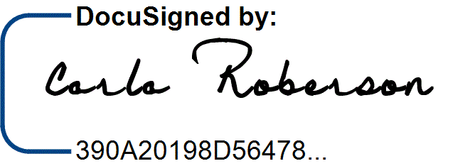
10/24/2023
Signature of soror making the committee report: _
Date of report to Executive Board/Chapter: 10/31/2023
Date/Time of next scheduled committee meeting; October 24, 2023

