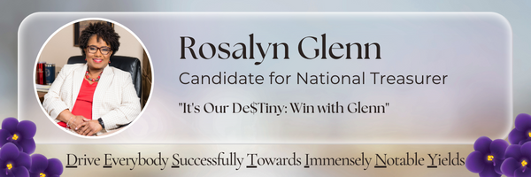
________________________________________________________________________
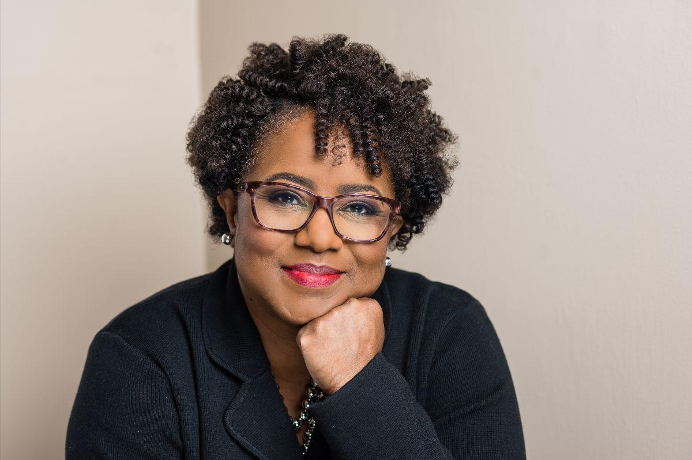
To My Fellow Sisters in Delta:

I am humbled and honored to be slated for the position of National Treasurer for our beloved Delta Sigma Theta Sorority, Inc.

It has been a pleasure to serve this Sensational Sisterhood for almost 35 years and now I want to continue my service in this executive leadership role, bringing to bear my more than 32 years in the financial services industry. I have demonstrated my ability to do the work as I currently serve on the National Strategic Planning Committee, have served as a member of the National Finance Committee, and have served in various regional and chapter level positions.

Please review my campaign website to learn more about my areas of expertise and my professional and Delta leadership experiences. I hope you will agree that I am more than qualified to carry out the responsibilities of the role. But for now, I’d like to share a little bit more about who I am.
