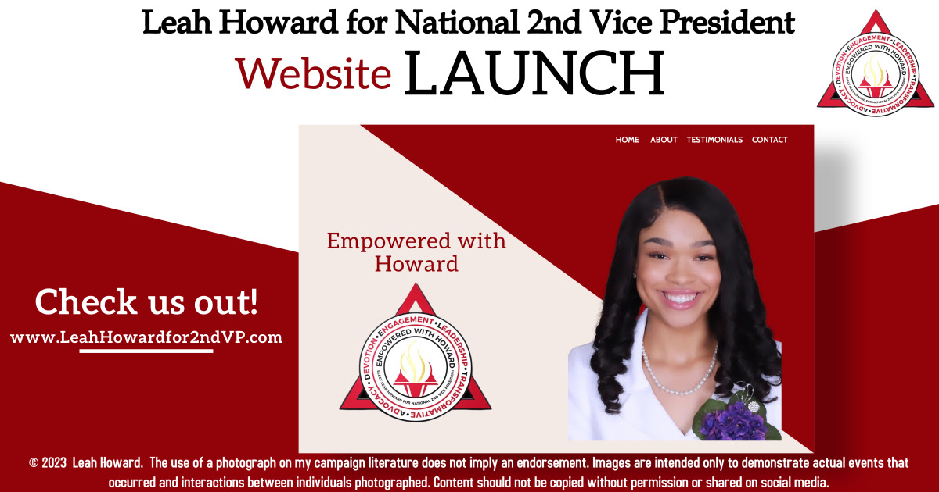

https://vimeo.com/830672055/786b8d107e?share=copy
EmpoweRED with Leah Howard
© 2023 Leah Howard. The use of a photograph on my campaign literature does not imply an endorsement. Images are intended only to demonstrate actual events that occurred and interactions between individuals photographed. Content should not be copied without permission or shared on social media.
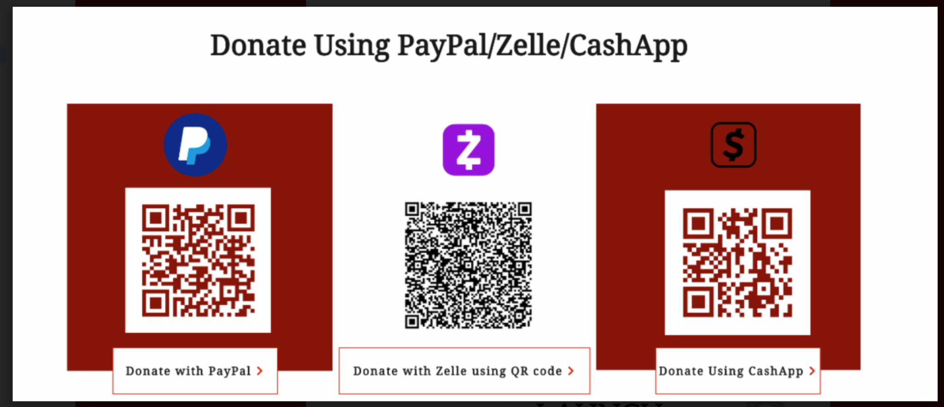
Check out my website here!

